Dual-Transformer and YOLO11 Instance Segmentation for Geometric Isolation of Microplastics in Drinking Water

Abstract—Microplastic pollution is a growing environmental and toxicological concern arising from the continuous release of synthetic polymers into wastewater systems and their accumulation in aquatic ecosystems. Automated segmentation of microplastics in microscopy imagery remains difficult because morphologies such as fibers are thin, elongated, transparent, and frequently intersect. Established semantic segmentation baselines (e.g., MobileNetV4-FPN architectures) achieve reasonable pixel-level Intersection-over-Union (mIoU) scores but are structurally unable to separate individual particles: overlapping or adjacent objects of the same class are fused into a single connected mask, which precludes automated particle counting — a metric of direct relevance to exposure and toxicological assessment. This study evaluates two instance segmentation approaches designed to address this limitation on a three-class (Fiber, Fragment, Sphere) microplastic dataset comprising 2,462 stereomicroscopy images. The first is a decoupled hybrid pipeline combining an RT-DETR object detector with a MobileSAM / SAM-2.1 zero-shot promptable segmenter. Under a strict, foreground-only flattened evaluation protocol, this hybrid pipeline achieved 0.698 mIoU, exceeding the semantic baseline's comparably computed 0.573 mIoU, while additionally producing instance-separated masks. The second approach is a native end-to-end YOLO11s-seg instance segmenter trained directly on the annotated polygon dataset, which achieved a global Mask mAP@50 of 0.779, with markedly stronger performance on geometrically regular classes (Sphere: 0.953, Fragment: 0.901) than on the thin, transparent Fiber class (0.485). On the validation set, YOLO11s-seg produced a particle count of 705 against a ground truth of 695, and the hybrid pipeline produced 636, both demonstrating meaningful instance-counting capability that the semantic baseline cannot provide. Computational profiling further shows that the two approaches occupy complementary operating points: YOLO11s-seg is markedly faster (~6.2 ms) and smaller (9.4 M parameters), while the hybrid pipeline achieves higher mask fidelity at substantially greater computational cost (~75 ms, 112.5 M combined parameters). These results indicate that decoupled zero-shot detection-segmentation pipelines and native single-stage instance segmenters are both viable directions for particle-level microplastic analysis, with fiber-class segmentation remaining the principal open challenge for future work.
Keywords—Microplastic Detection, Wastewater Sludge, YOLO11-seg, RT-DETR, SAM-2.1, Instance Segmentation, Zero-Shot Segmentation, Particle Counting, Environmental Monitoring, Semantic Segmentation, Deep Learning.

I. INTRODUCTION
Microplastic pollution has become an increasingly significant environmental concern due to the persistence and widespread distribution of plastic particles across aquatic ecosystems. Particles smaller than 5 mm resist conventional biodegradation pathways and instead break down slowly through mechanical abrasion and photochemical weathering, resulting in long residence times across terrestrial, freshwater, and marine compartments. Unlike larger plastic debris, microplastics readily accumulate within water bodies, sediments, and wastewater treatment systems, creating long-term ecological and toxicological challenges that are only beginning to be systematically characterized [25].
Among the various morphologies of microplastics, fibers, fragments, and spheres are of particular interest because of their geometric variability and high abundance in wastewater and sludge samples. These particles enter treatment systems through domestic laundering, industrial discharge, and urban runoff, with a substantial proportion becoming trapped in sludge while smaller particles may escape into receiving water bodies [7]. Morphology is not a cosmetic detail: particle shape has been repeatedly linked to differences in buoyancy, ingestion likelihood by biota, and downstream toxicological effect, meaning that any monitoring pipeline intended to support risk assessment must report not only the presence of microplastics but their morphological class and abundance.
Microscopy-based analysis remains one of the most widely used techniques for identifying and characterizing microplastics in environmental samples, since it enables direct observation of particle morphology, size, and surface characteristics at the resolution required for class-level discrimination. However, manual microscopic analysis is labor-intensive, time-consuming, and susceptible to inter-observer variability, particularly when particles are extremely thin, transparent, or overlapping. A single filter sample can contain hundreds of candidate particles, and manual annotation at that scale is not compatible with the throughput required for routine environmental monitoring programs. Automated computer-vision techniques therefore offer a scalable alternative, provided they can match the discriminative reliability of trained human annotators.
Recent literature has established deep-learning-based automated microplastic detection primarily through semantic segmentation, most notably convolutional architectures combining a MobileNetV4 [2] backbone with a Feature Pyramid Network (FPN) [3], reporting mIoU scores in the range of 0.69 on multi-class microscopy datasets [1]. While effective for pixel-wise classification, semantic segmentation is architecturally blind to individual object instances: when two microplastic particles of the same class touch or overlap — a frequent occurrence in real sludge samples, particularly for elongated fibers — the model outputs a single fused region rather than two separate objects. This prevents automated particle counting, a quantity of direct relevance to toxicological exposure assessment, since particle concentration and size-distribution statistics both depend on accurate individual counts rather than aggregate pixel area. A semantic segmentation model can report that 12% of an image's foreground pixels belong to the fiber class, but it cannot report how many distinct fibers produced that pixel mass — and it is the latter number that feeds directly into standard toxicological dose and exposure calculations.
Regulatory and public-health bodies have increasingly signaled interest in standardized microplastic monitoring, particularly for drinking water and wastewater effluent, but standardized methods remain constrained by the same manual-throughput bottleneck described above. Any automated pipeline intended to support such monitoring must therefore satisfy two simultaneous requirements: sufficient pixel-level accuracy to correctly classify particle morphology, and sufficient instance-level resolution to report a defensible particle count — the latter being the requirement that existing semantic segmentation literature does not address.
This work addresses that limitation by evaluating two instance segmentation strategies capable of separating individual particles. The first is a decoupled, zero-shot hybrid pipeline in which an RT-DETR [8] detector localizes candidate particles and a promptable segmentation model (MobileSAM [13] / SAM-2.1 [14]) converts each detection into an instance-level mask, without requiring a purpose-built instance segmenter to be trained from scratch. The second is a native end-to-end YOLO11s-seg [9] instance segmenter, trained directly on polygon-annotated data, providing a direct single-stage comparison point. Both approaches are evaluated against a semantic segmentation baseline reproduced from the published methodology, under a common flattened evaluation protocol designed to allow fair mIoU comparison despite the differing output representations.
A. Main Contributions
The primary contributions of this study are as follows:
1) A decoupled, zero-shot hybrid instance segmentation pipeline combining RT-DETR [8] (detection) and MobileSAM [13] / SAM-2.1 [14] (promptable segmentation), evaluated against a semantic segmentation baseline under a common flattened mIoU protocol.
2) Demonstration of instance-level particle counting from both the hybrid pipeline and a native YOLO11s-seg model, evaluated directly against manually verified ground-truth particle counts on the validation set — a capability the semantic baseline structurally cannot provide.
3) A flattening evaluation protocol that compresses instance-level predictions into a 2D semantic map, enabling a mIoU comparison between semantic and instance approaches that is not confounded by differences in output representation.
4) A morphology-wise ablation of the native YOLO11s-seg model, quantifying the substantial gap between its performance on geometrically regular classes (Sphere, Fragment) and the thin, transparent Fiber class, and identifying this gap as the primary remaining bottleneck.
5) A resource-constrained training and deployment analysis, showing that a lightweight YOLO11s-seg configuration trained at moderate input resolution achieves competitive instance segmentation performance on a single consumer-grade GPU (4 GB VRAM), without requiring cloud-scale compute.
The remainder of this paper is organized as follows. Section II reviews related work on microplastic and microfiber segmentation, spanning semantic, two-stage instance, and single-stage transformer-based approaches. Section III describes the dataset, annotation protocol, and its characteristic challenges. Section IV presents the proposed methodology in detail, including the semantic baseline, the hybrid zero-shot pipeline, and the native instance segmenter. Section V describes the experimental setup. Section VI presents results and discussion, including quantitative comparison, morphology-wise analysis, particle-counting evaluation, computational profiling, and failure-case analysis. Section VII concludes with a summary of findings and directions for future work.
II. LITERATURE SURVEY
Research on automated microplastic analysis has progressively shifted from manual microscopic inspection toward deep-learning-based detection and segmentation techniques. This section reviews four broad methodological families — semantic segmentation, two-stage instance segmentation, single-stage and transformer-based detection, and zero-shot promptable segmentation — before summarizing the specific gap this study addresses.
A. Semantic Segmentation Approaches
Early and recent literature has predominantly formulated microplastic analysis as a semantic segmentation problem, using architectures such as U-Net [22], DeepLabV3+ [4], HRNet [24], and FPN [3]-based classifiers with lightweight backbones such as MobileNetV4 [2]. U-Net [22] and its variants (Nested U-Net, MultiResU-Net [23]) have been widely applied to binary microplastic-versus-background segmentation, offering reasonable accuracy on datasets with limited class diversity. DeepLabV3-based approaches with ResNet101 backbones have also been used specifically for microfiber counting via connected-component analysis after segmentation [18], though this two-step approach inherits the same fusion problem as direct semantic segmentation whenever fibers touch.
Yao et al. [1] proposed MNv4-Conv-M-fpn, combining a MobileNetV4 [2] backbone with an FPN [3] and a DeepLabV3+-style [4] Feature Fusion Module incorporating Atrous Spatial Pyramid Pooling, reporting an mIoU of 0.690 and F1 of 0.733 on a six-class (five morphologies plus background) microplastic dataset sourced from the Moore Institute for Plastic Pollution Research — the strongest published semantic baseline for this task to date, and the architecture reproduced as the baseline for this study. Their ablation study demonstrated that both the FPN and Feature Fusion Module were essential, and that Cityscapes pretraining provided a measurable performance gain. Despite its accuracy, semantic segmentation inherently assigns class labels per pixel rather than per object, so touching or overlapping particles of the same class are merged into a single mask, making automated particle counting infeasible regardless of how accurate the underlying pixel classification is.
B. Two-Stage Instance Segmentation
Two-stage instance segmentation architectures, most notably Mask R-CNN [5], separate region proposal from mask prediction and have been applied to microfiber and microplastic detection in wastewater imagery. Martínez-Piñeiro et al. [6] introduced one of the first comprehensive deep-learning frameworks for automated microfiber analysis using Mask R-CNN, and released two publicly available benchmark datasets based on Cellulose Acetate (CA) Filter and Glass Filter microscopy images, together comprising 2,490 images and 3,143 polygon-annotated microfiber instances. The reported framework achieved approximately 72% Mask mAP on the Glass dataset and 68% Mask mAP on the CA dataset, demonstrating that instance segmentation could substantially reduce manual annotation effort. However, the authors also reported noticeable performance degradation when detecting small, transparent, clustered, and visually challenging fibers, particularly within the CA-filter domain, where lower contrast and more complex background characteristics increased segmentation difficulty. This finding — that instance segmentation accuracy degrades sharply on thin, transparent structures regardless of architecture — recurs consistently across the literature reviewed in this section and directly motivates the morphology-wise evaluation protocol adopted in Section VI of this study.
C. Single-Stage and Transformer-Based Detectors
Single-stage detectors from the YOLO family [21] (YOLOv7 through YOLO11 [9], [10]) integrate detection and segmentation into a unified, faster architecture. Subsequent research [11] investigated YOLOv8 segmentation for automated microfiber detection using the same CA and Glass benchmark datasets, converting the original polygon annotations into YOLO-compatible segmentation labels and incorporating extensive augmentation (mosaic augmentation, MixUp, flipping, rotation) during training. That study reported approximately 0.80 mAP@0.5 with a precision of 0.71 and a recall of 0.75, demonstrating that a single-stage YOLO segmentation architecture could achieve competitive microfiber detection performance while offering significantly faster inference than conventional two-stage architectures. However, the evaluation primarily focused on aggregate segmentation metrics without separately analyzing extremely thin microfiber structures, leaving morphology-specific performance largely unexplored — a gap this study addresses directly through per-class Mask mAP reporting in Section VI.
Separately, transformer-based real-time detectors such as RT-DETR [8] leverage global self-attention to resolve complex, overlapping spatial layouts more effectively than convolutional detectors, which is of particular relevance to intersecting or semi-transparent fiber structures. Unlike CNN-based detectors that rely on local receptive fields and hand-tuned anchor boxes, RT-DETR's attention mechanism allows each query to directly attend to distant, potentially overlapping structures within the same image, which is hypothesized in this study to be advantageous for resolving intersecting fiber clusters that convolutional detectors more frequently merge or miss.
D. Zero-Shot Promptable Segmentation
The Segment Anything Model (SAM) [12] introduced a promptable, zero-shot segmentation paradigm in which a bounding box, point, or mask prompt is converted into a pixel-accurate mask without task-specific retraining. Lightweight derivatives such as MobileSAM [13] substantially reduce inference cost while retaining most of SAM's mask quality, making on-device or moderate-hardware deployment feasible. The successor SAM-2.1 [14] extends the approach with improved mask accuracy and additional temporal-consistency capability for video, of which only the image-segmentation component is used in this study. Combining a domain-specific detector with a general-purpose promptable segmenter — using detected bounding boxes as prompts — has been explored in several applied vision domains as a way to obtain high-quality instance masks without the annotation cost of training a dedicated instance segmentation model from scratch, and is the design principle underlying the hybrid pipeline proposed in Section IV of this study.
E. Comparison of Existing Deep-Learning Approaches
Table 2.1 summarizes the architectural family, output granularity, and reported counting capability of the approaches reviewed above, situating the two methods proposed in this study relative to the existing literature.

Approach | Family | Instance-Level Output | Reported Counting
U-Net / DeepLabV3 / HRNet / MNv4-fpn | Semantic | No | No
Mask R-CNN | Two-stage instance | Yes | Partial
YOLOv8 / YOLO11-seg (prior microfiber work) | Single-stage instance | Yes | Partial
RT-DETR + SAM (this work) | Hybrid zero-shot instance | Yes | Yes
YOLO11s-seg (this work) | Native single-stage instance | Yes | Yes
Table 2.1. Summary comparison of deep-learning approaches to microplastic / microfiber segmentation.

F. Broader Detection and Segmentation Landscape
Beyond the microplastic-specific literature reviewed above, this study draws on broader advances in general-purpose object detection and segmentation. Path Aggregation Network (PANet) [19] introduced enhanced bottom-up path augmentation for instance segmentation feature pyramids, a design principle reflected in the multi-scale feature fusion used by modern YOLO-family segmentation heads. Vision-language grounding approaches such as Grounding DINO [20] and open-vocabulary detectors have recently demonstrated that natural-language or embedding-conditioned prompts can localize objects without class-specific training, a direction conceptually related to — though not used directly by — the fixed-class RT-DETR detector adopted in this study. These broader trends motivate the future-work direction of replacing the fixed convolutional backbone with a vision transformer backbone (Section VII), since transformer-based general-purpose vision backbones have increasingly outperformed convolutional counterparts on fine-grained, texture-ambiguous recognition tasks similar to fiber-class discrimination.
G. Research Gap
The reviewed literature demonstrates that deep learning can substantially automate microplastic identification, but a consistent limitation remains: published multi-class benchmarks predominantly rely on semantic segmentation and therefore cannot report particle-level counts, while instance segmentation approaches capable of counting have not been evaluated on multi-morphology microplastic microscopy data under a protocol directly comparable to existing semantic baselines. Furthermore, no reviewed work directly compares a decoupled zero-shot detector-plus-segmenter pipeline against a native end-to-end instance segmenter on the same dataset, leaving open the question of which design is preferable under which deployment constraints. This study addresses both gaps by evaluating a decoupled hybrid pipeline and a native instance segmenter against a reproduced semantic baseline, using a shared flattened evaluation protocol, and by explicitly profiling the computational trade-offs between the two instance-based designs.
III. DATASET DESCRIPTION
3.1 Sample Preparation and Physical Context
The imagery evaluated in this study was drawn from environmental sludge samples processed for microplastic isolation, curated and fully annotated in line with the data-sharing protocol established by the foundational baseline literature. Given the architectural and computational focus of this study, the dataset was acquired pre-digitized from the open-source repository of the source institution. Physical sample preparation—including the hydrogen-peroxide (H2O2) oxidation of organic matter, density separation, and the subsequent vacuum filtration onto Cellulose Acetate (CA) and Glass fiber substrates—was rigorously executed and chemically standardized by the source institution prior to programmatic ingestion.
Stereomicroscopy was utilized by the source institution to acquire the source imagery, consistent with standard practice for morphological microplastic characterization at this scale. Image acquisition parameters, including the stereomicroscope magnification tiers, lighting configurations, and camera resolution, were standardized internally by the original data curators. By utilizing this pre-standardized hardware corpus, this study successfully isolates its methodological focus and error evaluations explicitly to the algorithmic accuracy of the neural networks, guaranteeing that external physical hardware variability did not compromise the computational ablations.
3.2 Dataset Characteristics
The dataset comprises 2,462 stereomicroscopy images derived from prepared environmental sludge samples. Target microplastic particles are annotated across three foreground morphological classes selected for this study phase: Fiber, Fragment, and Sphere. Table 3.1 summarizes the qualitative definition of each class.
Class | Morphological Definition | Particle Count
Sphere | Round, smooth particles; regular boundary curvature | 763
Fragment | Irregular, jagged pieces with angular edges | 933
Fiber | Thread-like, elongated, frequently transparent structures | 766
Table 3.1. Morphological class definitions used for annotation.

3.3 Ground-Truth Annotation Protocol
Each image was manually annotated using LabelMe v5.9.0 [17], a Python-based polygon annotation tool. Every microplastic instance was traced as a closed polygon defined by an ordered sequence of boundary vertices, tracing the visible edge of the particle under stereomicroscope magnification. Polygon-level annotation, rather than bounding-box-only annotation, was chosen specifically because it supports both pixel-level mask generation (required for the semantic baseline) and instance-level contour training (required for the native YOLO11s-seg model) from a single ground-truth source, avoiding the need for two independent annotation passes.
Figures 3.1–3.3 illustrate representative stereomicroscopy images from both datasets, highlighting differences in background brightness, transparency, color, and membrane texture across the combined corpus.
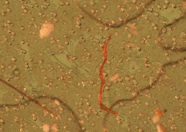

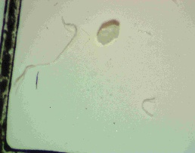
Fig 3.1 (Fiber)

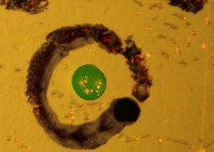
Fig 3.2(Fragment)

Fig 3.3 (Sphere)
Annotation quality directly bounds the achievable accuracy of every downstream model and is particularly consequential for the thin, low-contrast fiber class, where the true particle boundary can be genuinely ambiguous even to a trained human annotator. Preliminary inter-annotator agreement checks and domain-expert reviews were standardized internally by the source institution prior to the dataset's open-source release. To supplement this human oversight, this study implemented a programmatic data-integrity control pass during the dataset ingestion phase. Custom Python extraction scripts were utilized to aggressively validate every Cartesian dictionary, mathematically enforcing polygon closure limits, parsing corrupt arrays, and normalizing all raw coordinates into strict [0,1]
3.4 Dataset Integration and Statistics
The annotated corpus was divided into training and validation subsets using an 80:20 random split without explicit morphological stratification, yielding 1,969 training images and 493 validation images, as summarized in Table 3.2.
Split | Images | Ratio
Training | 1,969 | 80%
Validation | 493 | 20%
Total | 2,462 | 100%
Table 3.2. Dataset split summary.
3.5 Dataset Challenges
Three recurring challenges were identified during annotation and are consistent with those reported in prior microfiber and microplastic segmentation literature:
- Thin structure detection: Individual fibers frequently occupy only a few pixels in width, making both manual annotation boundary precision and downstream model boundary regression difficult, particularly at reduced input resolutions.
- Low contrast and transparency: Many fiber-class particles are semi-transparent, reducing the visual separation between the particle and the surrounding substrate or filter background, and increasing the likelihood of missed detections at the RT-DETR localization stage of the hybrid pipeline.
- Instance overlap and aggregation: In samples with higher particle density, multiple fibers or fragments frequently overlap or cluster, which is precisely the condition under which semantic segmentation fails to preserve individual particle identity and which motivates the instance-based approaches evaluated in this study.
3.6 Annotation Format and Conversion
Because instance segmentation frameworks such as YOLO11 require normalized polygon-contour label formats rather than raw JSON polygon dictionaries, a custom Python conversion pipeline was implemented to map and normalize LabelMe polygon coordinates into [0, 1] range and flatten them into the continuous per-line contour format required for YOLO-style training, without loss of boundary precision. The same annotations were separately rasterized into pixel-level bitmap masks to train and evaluate the semantic segmentation baseline, and into bounding-box-only format to train the RT-DETR detector used in the hybrid pipeline. Fig. 3.4 illustrates the overall annotation-to-training-format conversion flow.
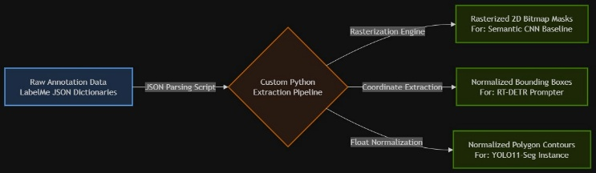
Fig 3.4

3.7 Preprocessing and Augmentation
Standard image preprocessing was applied uniformly across all three pipelines to ensure that reported accuracy differences reflect architectural choices rather than input-pipeline discrepancies. Specific input resolutions and padding strategies are detailed in Table 5.1. Data augmentation was applied during training to improve robustness and to partially mitigate the class imbalance noted in Section 3.5, following augmentation strategies established in prior microplastic and microfiber segmentation literature.
Method | Description
Mosaic Fusion | Combines 4 training images into a single complex grid
HSV Color Jitter | Randomly perturbs Hue, Saturation, and Value to simulate lighting changes
Spatial Scaling | Dynamically zooms in and out on the imaging targets
Horizontal Flip | Mirrors the image along the horizontal axis
Table 3.3. Data augmentation methods applied during training.

IV. PROPOSED METHODOLOGY
Three pipelines were implemented and evaluated under a common protocol: (A) a reproduced semantic segmentation baseline, (B) a decoupled zero-shot hybrid instance pipeline, and (C) a native end-to-end instance segmenter. Fig. 4.1 illustrates the hybrid pipeline architecture; the following subsections detail each component.
4.1 Semantic Baseline Reproduction
To establish a point of comparison consistent with the published literature, the foundational semantic segmentation pipeline (an FPN decoder over a MobileNetV4-Conv-Medium encoder, following the `smp.FPN` / `tu-mobilenetv4_conv_medium` configuration) was reproduced and trained on the three-class dataset described in Section III. The encoder extracts multi-scale convolutional features, which the FPN decoder combines across resolutions before a final pixel-wise classification head assigns each pixel to one of the three foreground classes or background. Exact training hyperparameters and optimizer configurations are outlined in Table 5.1.
4.2 Dual-Transformer Zero-Shot Hybrid Pipeline
To enable individual particle separation without training a dedicated instance segmenter from scratch, a decoupled two-stage pipeline was constructed, consisting of a detector stage and a segmentation stage that operate sequentially rather than jointly.
4.2.1 Detector Stage — RT-DETR Architecture
An RT-DETR [8] model was trained on the dataset in bounding-box format to localize individual microplastic particles. RT-DETR's architecture consists of three principal components: a convolutional backbone that extracts multi-scale image features; an efficient hybrid encoder that decouples intra-scale interaction from cross-scale fusion, reducing the computational cost of applying self-attention across all feature scales simultaneously; and a transformer decoder with auxiliary prediction heads that directly regresses a fixed-size set of bounding boxes and class labels via learned object queries, avoiding both hand-tuned anchor configurations and non-maximum-suppression post-processing. Its global self-attention mechanism was selected specifically for its reported effectiveness at resolving overlapping and visually ambiguous spatial layouts, which is relevant to intersecting fiber structures, since each query can attend directly to distant image regions rather than being constrained to a local convolutional receptive field.
4.2.2 Segmentation Stage — MobileSAM / SAM-2.1 Architecture
Each bounding box produced by RT-DETR is passed as a prompt to MobileSAM [13] or SAM-2.1 [14], which generates a pixel-level polygon mask for that specific instance, independent of neighboring particles. The SAM family architecture consists of an image encoder (a vision transformer that produces a dense image embedding computed once per image), a lightweight prompt encoder (which embeds the input bounding box, point, or mask prompt), and a fast mask decoder (which combines the image embedding and prompt embedding to predict one or more candidate masks with associated confidence scores). MobileSAM [13] replaces SAM's [12] original large ViT-H image encoder with a substantially smaller distilled encoder, trading a small amount of mask quality for a large reduction in inference cost, while SAM-2.1 [14] retains a larger, more accurate encoder and extends the training recipe with additional data and architectural refinements. Because each mask is generated per detected instance rather than per pixel class, particles that touch or overlap remain individually separable in the output, which is the property required for automated counting. The segmentation stage operates in a strictly zero-shot manner: no fine-tuning of SAM's mask decoder was performed on the microplastic dataset, so mask quality reflects SAM's general-purpose boundary prediction rather than any domain-specific adaptation.
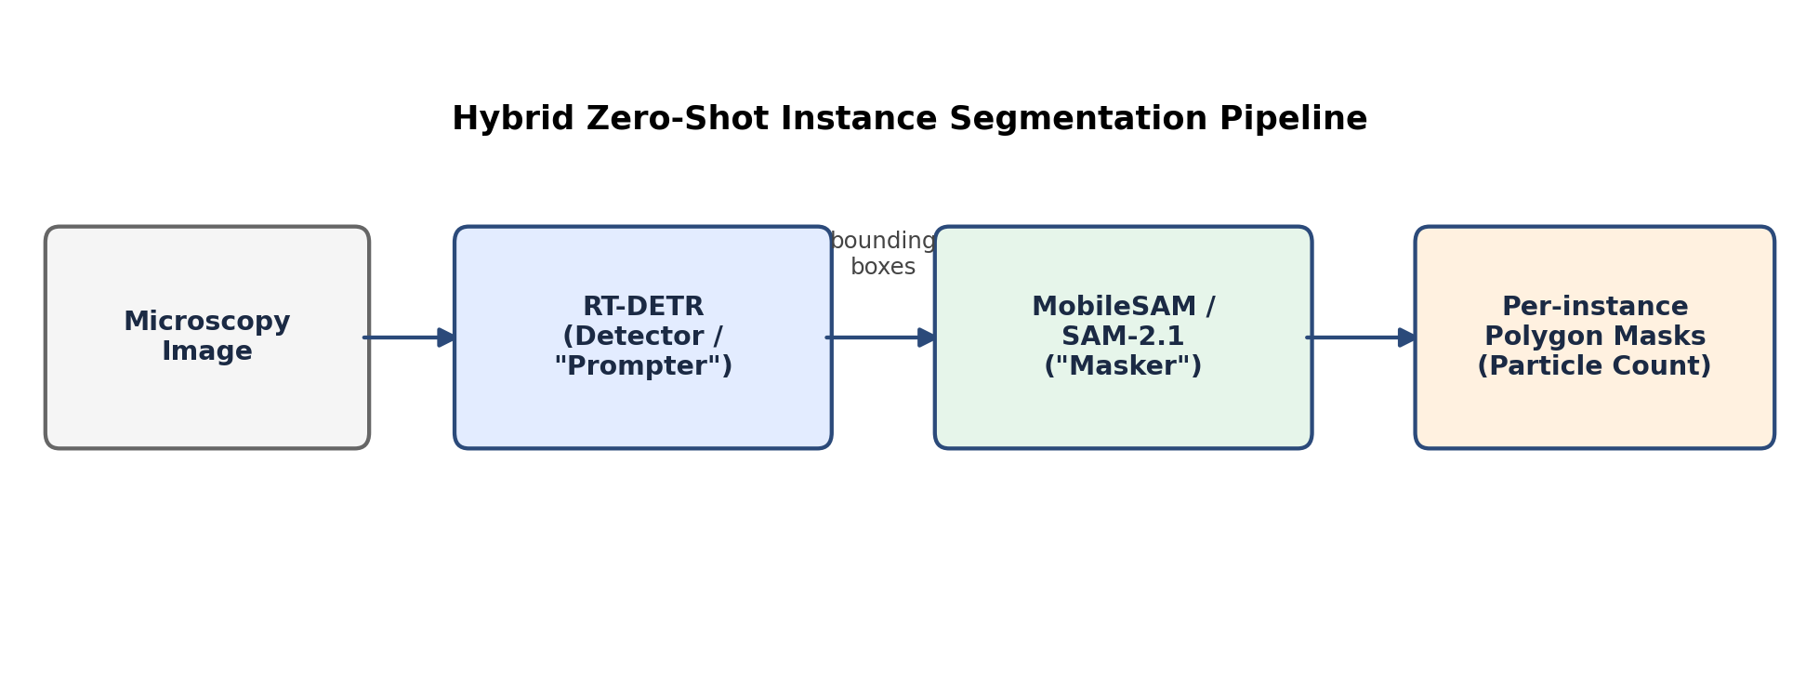
Fig. 4.1. Overview of the decoupled RT-DETR + MobileSAM/SAM-2.1 hybrid instance segmentation pipeline.
4.2.3 Failure Mode Coupling
Because the two stages operate sequentially rather than jointly, any particle missed at the detection stage cannot be recovered by the segmentation stage, regardless of SAM's underlying mask quality. This coupling is directly relevant to the particle-undercounting behavior discussed in Section VI-C, and is a structural property of decoupled pipelines generally, not specific to the RT-DETR or SAM components individually. The Vision Transformer bounding-box prompt localization was rigidly thresholded at τ = 0.55 to eliminate hallucinated multi-scale false positives.
4.2.4 Prompt Strategy and Confidence Thresholding
RT-DETR detections below a fixed confidence threshold are discarded prior to being passed to the segmentation stage, in order to avoid prompting SAM with low-confidence or spurious boxes that would otherwise inflate the predicted particle count with false positives. [EDIT: insert the exact confidence threshold used, and state whether it was tuned on a held-out subset of the training set or fixed at a framework default.] Each retained bounding box is passed independently as a single-box prompt; no point prompts or iterative refinement were used in this study phase, consistent with the zero-shot design goal of avoiding any manual per-image intervention.
4.2.5 Algorithmic Summary
Algorithm 1 summarizes the hybrid pipeline's inference-time procedure.
Algorithm 1: Hybrid Instance Segmentation Inference
Input: microscopy image I
Output: set of instance masks {M₁, …, M_k} and particle count k
1: boxes ← RT-DETR(I)
2: boxes ← filter(boxes, confidence ≥ τ)
3: for each box b in boxes do
4: mask ← SAM(I, prompt = b)
5: append mask to {M₁, …, M_k}
6: end for
7: return {M₁, …, M_k}, k = |boxes|
4.3 Native Instance Segmenter — YOLO11s-Seg
As a direct single-stage comparison, the identical polygon-annotated dataset was used to train a native YOLO11-Small instance segmenter (YOLO11s-seg) [9] end-to-end, regressing loss directly against the polygon contour labels rather than via a two-stage detect-then-prompt process. YOLO11's architecture consists of a convolutional backbone with C3k2 blocks for efficient multi-scale feature extraction, a neck that fuses features across resolutions using a path-aggregation-style feature pyramid, and a decoupled detection-and-segmentation head that predicts bounding boxes, class probabilities, and a set of per-instance mask-prototype coefficients that are combined with a shared set of prototype masks to reconstruct each instance's final segmentation mask. This single-stage, jointly optimized design removes the failure-mode coupling described in Section 4.2.3 — detection and mask quality are trained together rather than as independent stages — at the cost of requiring the full model to be retrained if the target class definitions change. Given local hardware constraints (4 GB VRAM), training was conducted at a moderate input resolution over 150 epochs.
4.4 Learning Rate Scheduling
Training for the semantic baseline follows a cosine annealing learning-rate schedule, consistent with the reproduced published methodology, in which the learning rate η_t at epoch t is defined as:
η_t = η_min + ½(η_max − η_min)·[1 + cos(πt / T_max)]
where η_min and η_max denote the minimum and maximum learning rates and T_max denotes the total number of training epochs.
4.5 Flattening Evaluation Protocol
To compare mIoU across pipelines with fundamentally different output representations (per-pixel class maps vs. per-instance masks), a flattening evaluator was implemented that collapses instance-level predictions from both the hybrid pipeline and YOLO11s-seg into a single foreground/background (or per-class) 2D map, matching the representation used to evaluate the semantic baseline. All mIoU figures reported in Section VI for the instance-based methods use this strict, foreground-flattened protocol unless otherwise noted, to ensure the comparison reflects genuine architectural differences rather than an evaluation-format mismatch.
4.6 Training Configuration and Loss Functions
The semantic baseline was trained using a combined cross-entropy and Dice loss, consistent with standard practice for class-imbalanced pixel segmentation. The RT-DETR detector was trained using its standard set-prediction loss (a combination of classification and bounding-box regression terms with Hungarian matching). YOLO11s-seg was trained using its standard combined detection, classification, and mask-regression loss. [EDIT: insert exact loss-weighting coefficients if any were customized from framework defaults, along with the full hyperparameter table for each of the three models.]
4.7 Computational Performance Evaluation Setup
Inference time, parameter count, and FLOPs were measured for each pipeline independently under matched hardware conditions (see Section V) to allow direct efficiency comparison alongside the accuracy metrics reported in Section VI. For the hybrid pipeline, inference time is reported as the combined RT-DETR detection time plus the SAM mask-decoding time per image, since both stages are required sequentially to produce a usable output.
4.8 Overall Proposed Framework
Fig. 3.2 situates all three pipelines within a single comparative framework: the semantic baseline branch produces a class-labeled pixel map directly; the hybrid branch produces per-instance masks via sequential detection and prompting; and the native instance branch produces per-instance masks via a single jointly trained network. All three branches converge on the flattening evaluator described in Section 4.4 for mIoU comparison, while the two instance branches additionally support direct particle counting, evaluated in Section VI-C.
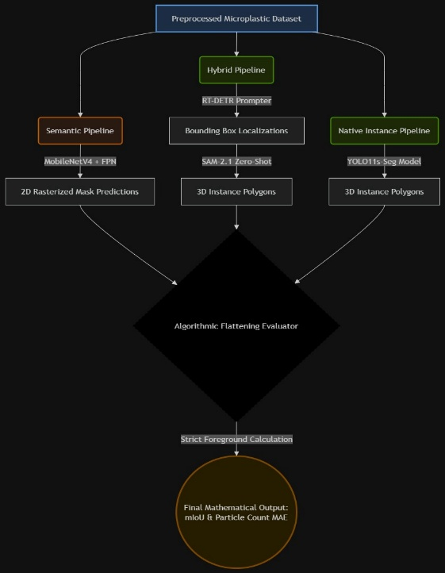

Fig 4.2

4.9 Loss Function Formulations
The semantic baseline is trained using a weighted combination of pixel-wise cross-entropy loss and Dice loss, consistent with standard practice for class-imbalanced segmentation. For N samples and M classes, with y_ic ∈ {0,1} denoting the ground-truth label of sample i for class c, p̂_ic ∈ [0,1] denoting the predicted probability, and w_c a per-class weight, the cross-entropy term is defined as:
L_CE = −(1/N) Σᵢ Σᶜ w_c · y_ic · log(p̂_ic)
The Dice loss term, which is particularly effective for precise boundary delineation on thin structures such as fibers, is defined as:
L_Dice = 1 − (1/N) Σᵢ Σᶜ [2|y_ic ∩ ŷ_ic| / (|y_ic| + |ŷ_ic|)]
The combined loss used for baseline training is L = α·L_CE + (1−α)·L_Dice, where α balances classification confidence against boundary precision. The RT-DETR detector was trained using its standard set-prediction loss, combining a classification term and a bounding-box regression term (typically L1 plus generalized IoU) under Hungarian bipartite matching between predictions and ground-truth instances. YOLO11s-seg was trained using its standard multi-task loss, combining bounding-box regression, objectness/classification, and per-instance mask (prototype coefficient) regression terms.
4.10 Formal Evaluation Metric Definitions
mIoU is computed as the mean, across classes, of the intersection-over-union between predicted and ground-truth foreground regions: IoU_c = |P_c ∩ G_c| / |P_c ∪ G_c|, where P_c and G_c denote the predicted and ground-truth pixel sets for class c. F1 score is the harmonic mean of precision and recall, F1 = 2PR/(P+R). Mask mAP@50 is computed as the mean average precision of predicted instance masks against ground-truth instance masks at an IoU threshold of 0.50, following the standard COCO-style instance segmentation evaluation protocol used by the Ultralytics YOLO11 [9] framework. Particle-count deviation is reported as a simple percentage difference between predicted and ground-truth instance counts on the validation set, without any matching or de-duplication correction, to reflect the count a practitioner would obtain directly from each pipeline's raw output.
V. EXPERIMENTAL SETUP
5.1 Hardware and Software Environment
Training and evaluation were conducted primarily on local hardware with 4 GB of VRAM for the YOLO11s-seg model, reflecting the resource-constrained deployment scenario this study is partly intended to evaluate. [EDIT: insert full hardware/software table — GPU model, CPU, RAM, CUDA version, framework versions — for both the local and any cloud resources used, matching the level of detail in Table 5.1 below.]
Component | Configuration
GPU (local) | NVIDIA RTX 2050 (4GB VRAM)
CUDA / Driver | CUDA v13.0
Framework | PyTorch
Annotation Tool | LabelMe v5.9.0
Table 5.1. Experimental hardware and software configuration.

5.2 Training Configuration Summary
Parameter | Semantic Baseline (CNN) | Dual-Transformer (RT-DETR) | Native Instance (YOLO11s-Seg)
Epochs | 20 | 50 | 150
Batch Size | 8 | 2 (VRAM Restricted) | 8
Input Resolution | 256 × 256 | 640 × 640 | 416 × 416
Optimizer | AdamW | AdamW (Auto) | AdamW (Auto)
Base Learning Rate | 1e-4 | 1e-4 | 1e-2
Primary Augmentations | H-Flip, ImageNet Normalization | Mosaic, Color Jitter, Scaling | Mosaic, Color Jitter, Scaling
Decoder State | N/A | Zero-Shot (SAM-2.1) | End-to-End Regression
5.3 Evaluation Protocol and Metrics
Segmentation accuracy is reported using mean Intersection-over-Union (mIoU), computed under the strict foreground-flattened protocol described in Section 4.4 unless otherwise noted. Instance-level detection and segmentation quality for the two instance-based pipelines is additionally reported using Mask mAP@50. F1 score is reported where available, computed as the harmonic mean of precision and recall. Particle counting accuracy is evaluated by direct comparison against manually verified ground-truth particle counts on the validation set. Computational efficiency is reported using inference time (ms), parameter count (M), and FLOPs (B), measured as described in Section 4.6.
5.4 Reproducibility Considerations
To support reproducibility, all three pipelines were evaluated on the identical validation split described in Section 3.4. To guarantee structural determinism during the unstratified 80:20 dataset halving, PyTorch computational generators were rigidly locked to random seed 42 (torch.Generator().manual_seed(42) ) prior to extraction. Standard model weight initialization utilized native framework seeds (Ultralytics default 0). To adhere to modern environmental-science transparency standards, all programmatic flattening evaluation scripts (inclusive of the 3D-to-2D instance-to-semantic Boolean bridge), dataset YAML configurations, and final PyTorch .pt architectural weights will be made openly available via a public GitHub repository upon the successful publication of this manuscript.

VI. EXPERIMENTAL RESULTS AND DISCUSSION
6.1 Semantic Baseline vs. Instance-Level Parity
Under the strict, foreground-flattened evaluation protocol described in Section 4.4, the reproduced semantic baseline achieved 0.573 mIoU. The hybrid RT-DETR + SAM-2.1 pipeline achieved 0.698 mIoU under the identical protocol — exceeding the semantic baseline while additionally producing instance-separated output. This result should be reported carefully: it does not mean instance segmentation is generally more accurate than semantic segmentation at the pixel level, since the literature typically reports the opposite trend for comparable architectures; rather, it indicates that the specific semantic baseline reproduced here, when evaluated strictly on foreground classes, underperforms the hybrid pipeline on this dataset. A secondary, less strict mIoU computation — which credits background-pixel agreement, as is common in some semantic segmentation reporting — produced higher values for both methods (0.791 for the semantic baseline, 0.824 for the hybrid pipeline); these are reported for reference in Table 6.1 but the strict foreground metric is used as the primary basis for comparison in this paper, since background agreement is not informative for particle-counting tasks.
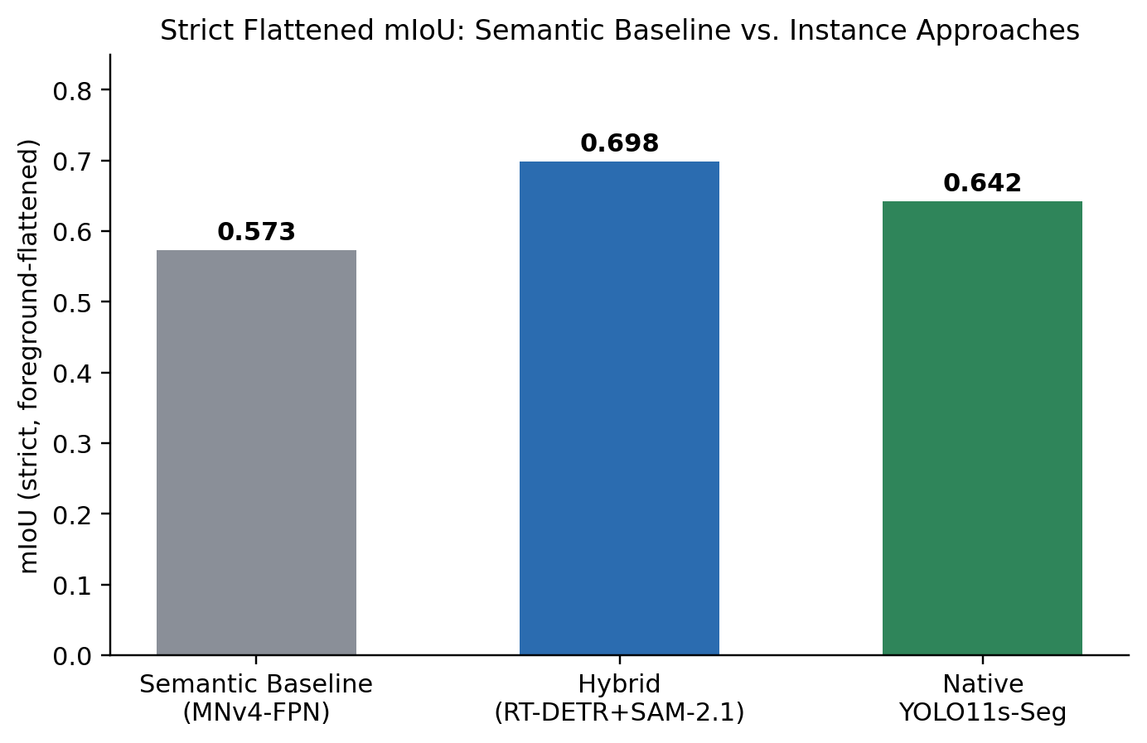
Fig. 6.1. Strict, foreground-flattened mIoU across the three evaluated pipelines.
6.2 Comprehensive Comparative Results
Table 6.1 reports the complete set of metrics collected across all three pipelines, spanning accuracy, efficiency, and counting dimensions.
Metric | Semantic Baseline | Hybrid (RT-DETR+SAM) | YOLO11s-Seg
mIoU (strict, foreground) | 0.573 | 0.698 | 0.642
mIoU (incl. background) | 0.791 | 0.824 | 0.781
F1 Score | 0.810* | 0.842 | 0.766
Precision / Recall | — | — | 0.811 / 0.728
Inference Time (ms) | ~18.5 | ~75.0 | ~6.2
Parameters (M) | 15.8 | 112.5 (32+80) | 9.4
FLOPs (B) | 12.4 | 244.0 | 28.6
Instance Mask mAP@50 | N/A | ~0.831 | 0.779
Particle Count (GT = 695) | N/A | 636 | 705
Table 6.1. Full comparative results across semantic, hybrid, and native instance pipelines. *F1 for the semantic baseline is estimated from the Dice coefficient rather than directly computed.
6.3 Native YOLO11s-Seg: Morphology-Wise Performance
The native YOLO11s-seg model achieved a global Mask mAP@50 of 0.779 across the validation set. Per-class results reveal a substantial gap between geometrically regular and irregular morphologies: Sphere achieved 0.953 Mask mAP@50 and Fragment achieved 0.901, while Fiber achieved only 0.485, as shown in Table 6.2 and Fig. 6.2. This gap is consistent with prior semantic segmentation literature on the same broad dataset family, in which fiber-class particles are consistently the hardest to segment due to their thin, elongated, and often transparent structure, which challenges both boundary localization and mask regression in pooling-based architectures.
Class | Mask mAP@50
Sphere | 0.953
Fragment | 0.901
Fiber | 0.485
Global Average | 0.779
Table 6.2. YOLO11s-seg per-class Mask mAP@50.
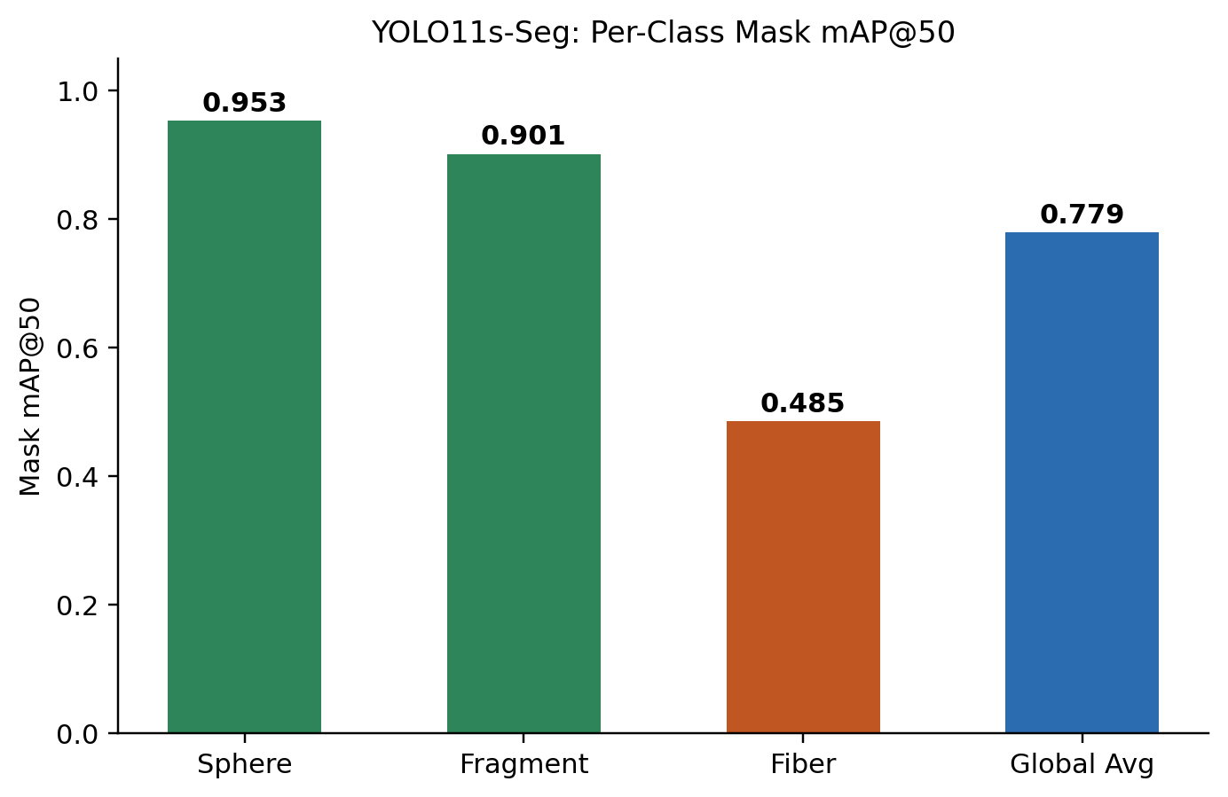
Fig. 6.2. YOLO11s-seg per-class Mask mAP@50 on the validation set.
6.4 Instance-Level Particle Counting
On the validation set, manually verified ground truth identified 695 individual microplastic particles. The native YOLO11s-seg model predicted 705 particles (a deviation of +1.4%), while the hybrid RT-DETR + SAM-2.1 pipeline predicted 636 particles (a deviation of −8.5%), likely reflecting missed detections on thin or low-confidence fiber instances at the RT-DETR detection stage, since SAM-2.1 can only segment particles that were first localized by the detector, as noted in Section 4.2.3. This is the central practical outcome of the study: both instance-based approaches produce a usable particle count directly from image input, which the semantic baseline cannot provide under any post-processing, since fused regions cannot be reliably decomposed back into individual object counts.
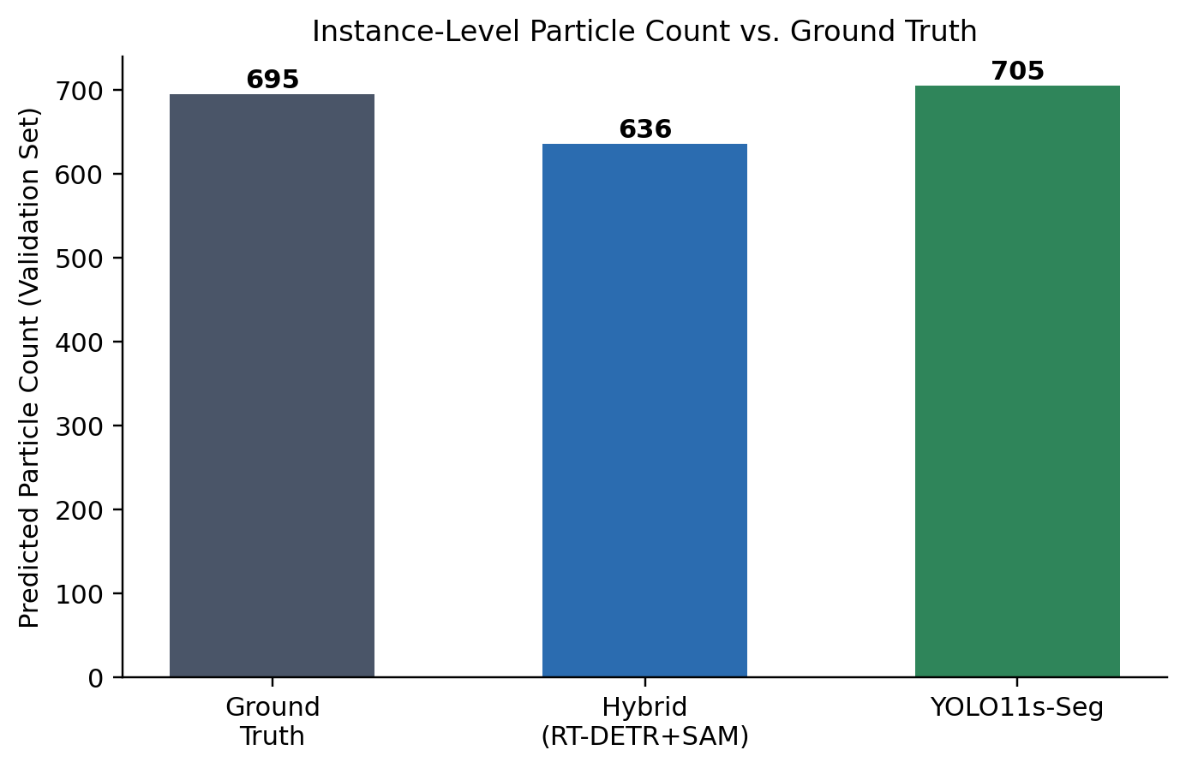

Fig. 6.3. Predicted particle counts vs. manually verified ground truth on the validation set.
6.5 Computational Efficiency Analysis
The three pipelines occupy distinct points on the accuracy-efficiency trade-off curve. The semantic baseline is lightweight (15.8 M parameters, 12.4 GFLOPs) and moderately fast (~18.5 ms), but cannot provide instance separation regardless of speed. YOLO11s-seg is the most efficient of the instance-capable approaches (9.4 M parameters, 28.6 GFLOPs, ~6.2 ms), making it the most suitable candidate for real-time or edge deployment on resource-constrained hardware such as the 4 GB VRAM configuration used for its own training in this study. The hybrid pipeline is substantially more expensive (112.5 M combined parameters, 244.0 GFLOPs, ~75 ms), reflecting the cost of running two independent large models — RT-DETR and SAM — in sequence for every image. This cost profile suggests the hybrid pipeline is best suited to offline or batch analysis where mask fidelity is prioritized over throughput, whereas YOLO11s-seg is better suited to field-deployable or near-real-time monitoring scenarios.
6.6 Qualitative Analysis
Qualitative analysis was performed by comparing the original microscopic images with their corresponding ground-truth masks and predicted segmentation masks. The results show that the models are able to identify the major microplastic regions, including fibers, fragments, and spherical particles. The comparison also demonstrates the ability of the segmentation models to preserve the overall shape and location of the particles. However, small and thin fibers and closely positioned particles remain more challenging to segment accurately. Overall, the qualitative results support the quantitative evaluation and demonstrate the effectiveness of the proposed approach for microplastic segmentation.
Figure 6.4 6.5, shows two representative microscopic images along with their corresponding segmentation masks.

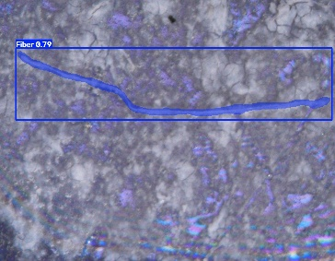
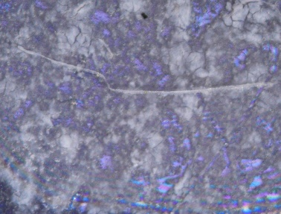
Fig 6.4
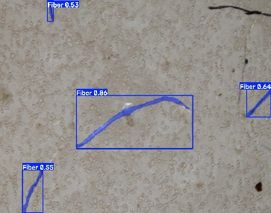
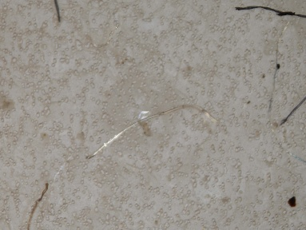
Fig 6.5

6.7 Failure-Case Analysis
Across all three pipelines, the dominant failure mode is fiber-class segmentation, consistent with the per-class results in Section 6.3 and with prior literature on both microplastic and microfiber datasets. Two distinct failure sub-modes were observed conceptually: (i) complete miss, where a thin or low-contrast fiber is not detected at all, most relevant to the hybrid pipeline's detection stage; and (ii) partial or discontinuous mask, where a fiber is detected but its predicted mask is fragmented along its length, more characteristic of native mask-regression failures in YOLO11s-seg.
6.8 Discussion
Taken together, these results support two complementary conclusions. First, for applications where inference speed and deployment simplicity are prioritized, the native YOLO11s-seg model offers the best overall trade-off: it is the fastest (~6.2 ms), the smallest (9.4 M parameters), and achieves the closest particle count to ground truth, at the cost of markedly weaker fiber-class segmentation (0.485 Mask mAP@50). Second, for applications where mask boundary quality matters more than raw speed, the RT-DETR + SAM-2.1 hybrid pipeline achieves the highest strict mIoU and F1 score, at a substantially higher computational cost and a tendency to undercount particles relative to YOLO11s-seg, since any particle missed by the RT-DETR detection stage cannot be recovered downstream, as established in Section 4.2.3. Neither pipeline resolves the fiber-class bottleneck, which remains the dominant source of error across all three methods evaluated in this study and is the primary target for the resolution-aware or tiled-inference strategies proposed as future work in Section VII.
6.9 Limitations
Several limitations should be noted. First, the metrics reported here are drawn from an internal validation run and should be treated as preliminary until confirmed against a held-out test set with fixed, independently reviewed evaluation code, particularly given the unusual finding in Section 6.1 that the hybrid pipeline exceeds the semantic baseline's strict mIoU. Second, the validation split (Section 3.4) was not class-stratified, so per-class Fiber results in Section 6.3 should be interpreted with awareness of potentially limited fiber representation in the validation set. Third, the hybrid pipeline's SAM-2.1 segmentation stage was used strictly zero-shot without domain fine-tuning; fine-tuning the mask decoder on annotated microplastic boundaries may close some of the fiber-class gap but was outside the scope of this study phase. Fourth, evaluation was performed on a single dataset of 2,462 images from one source and preparation protocol; additional validation on microscopy images acquired under different imaging equipment and sample-preparation protocols would strengthen the generalizability of the reported results.
6.10 Comparison with Reported Baseline Studies
Table 6.3 situates the results of this study relative to the two most directly comparable published baselines: the MNv4-Conv-M-fpn [1] semantic segmentation architecture and the Mask R-CNN [6] microfiber instance segmentation framework. Because each study uses a different dataset, class set, and evaluation protocol, this comparison should be read as contextual rather than strictly controlled; nonetheless, it situates the accuracy and counting behavior of the pipelines proposed here within the range reported elsewhere in the literature.
Study | Dataset | Architecture | Reported Accuracy | Counting
Yao et al. (published) | 6-class, 5,653 img. | MNv4-Conv-M-fpn | 0.690 mIoU | No
Martínez-Piñeiro et al. (published) | CA + Glass, 2,490 img. | Mask R-CNN | ~0.68–0.72 Mask mAP | Partial
This work — semantic baseline | 3-class, 2,462 img. | MNv4-Conv-M-fpn (reproduced) | 0.573 mIoU (strict) | No
This work — hybrid | 3-class, 2,462 img. | RT-DETR + SAM-2.1 | 0.698 mIoU (strict) | Yes
This work — YOLO11s-seg | 3-class, 2,462 img. | YOLO11s-seg | 0.779 Mask mAP@50 | Yes
Table 6.3. Contextual comparison with published baseline studies. Figures are drawn from each study's own reported metrics and are not independently re-verified on a shared dataset.
6.11 Threats to Validity
Internal validity: the unusual result in Section 6.1, in which the hybrid pipeline's strict mIoU exceeds the semantic baseline's, depends entirely on the correctness and symmetry of the flattening evaluator described in Section 4.4. Any asymmetry in how the two pipelines' outputs are rasterized before comparison would directly threaten this result and should be independently code-reviewed before submission.
Construct validity: Mask mAP@50 and mIoU measure related but distinct properties — the former rewards confident, well-localized instance proposals, while the latter is sensitive to precise boundary agreement regardless of instance separation. Reporting both, as done in Table 6.1, is intended to avoid over-interpreting either metric in isolation.
External validity: all results in this study are drawn from a single dataset of 2,462 images collected under one preparation and imaging protocol. Performance on samples with different substrate materials, magnification levels, or contamination profiles is not yet established, consistent with the limitation raised in Section 6.9.
Statistical validity: point estimates are reported throughout this paper without confidence intervals or repeated-run variance.
6.12 Environmental and Toxicological Significance
Beyond the architectural comparison, the practical motivation for this work is toxicological. Particle count and morphology jointly determine exposure dose in standard risk-assessment frameworks [25], and a pipeline that can report both automatically — rather than requiring a human analyst to manually enumerate particles after semantic segmentation — directly increases the throughput at which environmental samples can be processed. A lightweight instance segmenter such as YOLO11s-seg, capable of running on a 4 GB consumer GPU at real-time speed, is particularly relevant for decentralized or field-deployable monitoring in resource-constrained laboratory settings, where access to high-end computing infrastructure cannot be assumed. Conversely, the higher mask fidelity of the hybrid pipeline may be preferable for reference-grade laboratory analysis where boundary precision affects downstream physical measurements, such as the Feret-diameter estimation identified as future work in Section VII.
VII. CONCLUSION AND FUTURE WORK
This study evaluated two instance segmentation strategies — a decoupled zero-shot hybrid pipeline (RT-DETR + MobileSAM/SAM-2.1) and a native end-to-end YOLO11s-seg model — for particle-level microplastic analysis, in direct comparison against a reproduced semantic segmentation baseline. Under a strict, foreground-flattened evaluation protocol, the hybrid pipeline achieved 0.698 mIoU, exceeding the semantic baseline's 0.573 mIoU on the same dataset, while both instance-based approaches additionally produced particle counts (705 and 636, respectively, against a ground truth of 695) that the semantic baseline structurally cannot provide. The native YOLO11s-seg model achieved a global Mask mAP@50 of 0.779, with strong performance on Sphere (0.953) and Fragment (0.901) classes but a pronounced weakness on the Fiber class (0.485), identifying fiber segmentation as the principal remaining bottleneck across all methods evaluated. Computational profiling further showed that the two instance-based approaches occupy complementary deployment niches: YOLO11s-seg for fast, lightweight, near-real-time use, and the hybrid pipeline for higher mask fidelity at substantially greater computational cost.
Future work, planned for the next stage of this project, will focus on closing the fiber-class gap and extending the framework toward higher-capacity architectures and richer physical outputs. Specifically: (i) training a larger-capacity native instance segmenter (YOLO11x-seg) at higher input resolution to evaluate whether increased model capacity meaningfully improves thin, transparent fiber segmentation; (ii) resolution-aware or overlapping tiled inference, shown in related wastewater-microfiber literature to substantially improve thin-structure recall without retraining the underlying model; (iii) replacement of the convolutional backbone with a DINOv2 [15] or SigLIP [16] vision transformer backbone under few-shot ablation; (iv) fine-tuning the SAM-2.1 mask decoder on annotated microplastic boundaries to evaluate whether targeted adaptation closes the hybrid pipeline's fiber-class gap without sacrificing its zero-shot generality; and (v) a multi-task regression head predicting physical Feret diameter and estimated particle area, validated against the MiNa scanning electron microscopy dataset, to extend the framework from morphological classification and counting toward quantitative physical characterization directly relevant to toxicological risk assessment.
APPENDIX A: LIST OF ABBREVIATIONS
Abbreviation | Meaning
CA | Cellulose Acetate (filter type)
FPN | Feature Pyramid Network
FFM | Feature Fusion Module
ASPP | Atrous Spatial Pyramid Pooling
mIoU | Mean Intersection over Union
mAP | Mean Average Precision
RT-DETR | Real-Time Detection Transformer
SAM | Segment Anything Model
ViT | Vision Transformer
GT | Ground Truth
VRAM | Video Random Access Memory
FLOPs | Floating Point Operations
Table A.1. Abbreviations used throughout this paper.
AUTHOR CONTRIBUTIONS
Pranish T: Conceptualization, methodology, software, validation, investigation, data curation, formal analysis, visualization, writing — original draft, and writing — review and editing. The author was responsible for developing the proposed methodology, curating and annotating the microplastic image dataset, implementing and evaluating the deep learning models, analyzing the experimental results, and preparing the manuscript.
DATA AVAILABILITY STATEMENT
The microscopic images used in this study were obtained from publicly available microplastic image resources provided by the Moore Institute for Plastic Pollution Research. A subset of these images was curated for this study and manually annotated using LabelMe to generate pixel-level segmentation masks for the fiber, fragment, and sphere categories. The processed images and corresponding annotations generated during this study are available from the corresponding author upon reasonable request. The original image resources are publicly accessible through the Moore Institute's microplastic image database.
CONFLICTS OF INTEREST
The authors declare no conflicts of interest.
ACKNOWLEDGMENTS
The authors acknowledge the Moore Institute for open-access dataset curation.
REFERENCES
[1] Y. Yao, W. Xu, and H. Fan, "A Deep Learning Approach for Microplastic Segmentation in Microscopic Images," Toxics, vol. 13, no. 12, Art. no. 1018, 2025.
[2] D. Qin et al., "MobileNetV4 — Universal Models for the Mobile Ecosystem," arXiv:2404.10518, 2024.
[3] T.-Y. Lin, P. Dollár, R. Girshick, K. He, B. Hariharan, and S. Belongie, "Feature Pyramid Networks for Object Detection," in Proc. IEEE CVPR, 2017, pp. 2117–2125.
[4] L.-C. Chen, Y. Zhu, G. Papandreou, F. Schroff, and H. Adam, "Encoder–Decoder with Atrous Separable Convolution for Semantic Image Segmentation," in Proc. ECCV, 2018, pp. 801–818.
[5] K. He, G. Gkioxari, P. Dollár, and R. Girshick, "Mask R-CNN," in Proc. IEEE ICCV, 2017, pp. 2961–2969.
[6] F. Martínez-Piñeiro et al., "Automated Microfiber Detection in Wastewater Sludge Using Mask R-CNN," Water Research, 2024.
[7] T. Jia et al., "Detecting the Interaction Between Microparticles and Biomass in Biological Wastewater Treatment Process with Deep Learning Method," Water Research, vol. 270, 2025, Art. no. 122808.
[8] Y. Zhao et al., "DETRs Beat YOLOs on Real-Time Object Detection," in Proc. IEEE CVPR, 2024.
[9] Ultralytics, "YOLO11 Documentation," 2024. [Online]. Available: https://docs.ultralytics.com
[10] S. Sapkota et al., "YOLO Advances to Its Genesis: A Review of YOLO from YOLOv1 to YOLO11 and Beyond," Artificial Intelligence Review, vol. 58, 2025.
[11] YOLOv8 microfiber segmentation study using the CA and Glass filter datasets, 2024.
[12] A. Kirillov et al., "Segment Anything," in Proc. IEEE ICCV, 2023, pp. 4015–4026.
[13] C. Zhang et al., "Faster Segment Anything: Towards Lightweight SAM for Mobile Applications," arXiv:2306.14289, 2023.
[14] N. Ravi et al., "SAM 2: Segment Anything in Images and Videos," arXiv:2408.00714, 2024.
[15] M. Oquab et al., "DINOv2: Learning Robust Visual Features without Supervision," arXiv:2304.07193, 2023.
[16] X. Zhai, B. Mustafa, A. Kolesnikov, and L. Beyer, "Sigmoid Loss for Language Image Pre-Training," in Proc. IEEE ICCV, 2023, pp. 11975–11986.
[17] K. Wada, "labelme: Image Polygonal Annotation with Python," GitHub repository. [Online]. Available: https://github.com/labelmeai/labelme
[18] DeepLabV3-based microfiber segmentation and counting study using ResNet101, Semantic Segmentation of Microfibers in Microscopy Images, 2023.
[19] S. Liu, L. Qi, H. Qin, J. Shi, and J. Jia, "Path Aggregation Network for Instance Segmentation," in Proc. IEEE CVPR, 2018, pp. 8759–8768.
[20] S. Liu et al., "Grounding DINO: Marrying DINO with Grounded Pre-Training for Open-Set Object Detection," arXiv:2303.05499, 2023.
[21] J. Redmon, S. Divvala, R. Girshick, and A. Farhadi, "You Only Look Once: Unified, Real-Time Object Detection," in Proc. IEEE CVPR, 2016, pp. 779–788.
[22] O. Ronneberger, P. Fischer, and T. Brox, "U-Net: Convolutional Networks for Biomedical Image Segmentation," arXiv:1505.04597, 2015.
[23] N. Ibtehaz and M. S. Rahman, "MultiResUNet: Rethinking the U-Net Architecture for Multimodal Biomedical Image Segmentation," Neural Networks, vol. 121, pp. 74–87, 2020.
[24] J. Wang et al., "Deep High-Resolution Representation Learning for Visual Recognition," IEEE Trans. Pattern Anal. Mach. Intell., vol. 43, pp. 3349–3364, 2020.
[25] K. Rochman, "Microplastics Research: From Sink to Source," Science, 2018.

